COMMUNIQUE OF THE 13TH ANNUAL GENERAL MEETING OF THE EASTERN AFRICA
ASSOCIATION OF ANTI-CORRUPTION AUTHORITIES HEL.D AT SPEKE RESORT AND
CONFERENCE CENTRE, MUNYONYO, KAMPALA - UGANDA 19TH - 22ND NOVEMBER 2019

We, the Heads and Representatives of the member institutions of the Eastern Africa Association of Anti-Corruption Authorities, having held the 13TH Annual General Meeting from 19TH to 22nd November 2019 in Kampala, Uganda in accordance with -Article 9 (5) (a) of the EAAACA Constitution which states that the meeting shall be held once every year;

Noting that the theme of the meeting is: "Strengthening Regional Collaboration
to Prevent and Combat Corruption";

Recognizing that Regional Collaboration is very pertinent in the fight against corruption;

Acknowledging that the Anti-Corruption Authorities need to broaden synergies in having effective asset recovery in the region;

Appreciating the Inspectorate of Government of Uganda, for hosting the EAAACA 20th Executive Committee Meeting and the 13th Annual General Meeting;

Further appreciating the support of the development partners in strengthening regional collaboration to effectively prevent and combat corruption;

Having been addressed by the Chief Justice of the Republic of Uganda, Hon Bart Katureebe, and the Speaker of the Republic of Uganda, Rt. Hon. Rebecca Kadaga and having discussed presentations and contributions;

Have resolved that:
- Regional Collaboration is vital in Preventing and Combating Corruption and Asset Recovery;

- A team of legal experts to harmonize the position on East Africa Community (EAC) Protocol on Preventing and Combating Corruption to be convened in Tanzania. The meeting will be hosted by PCCB by December 2019. Nominations by the member countries to be made by December 1 5th 2019,
and the position to be presented to the Secretary General of EAC;
)

- There is need to document activities of the member institutions, especially inter-member activities to show the benefits of the collaboration. These will be compiled and shared amongst members and partners;

- The President will write a letter visit to Burundi about the payment of subscription and the in-coming President of EAAACA and General Secretary will visit Burundi and deliver the letter to their relevant authority.
- The EXCOM to recruit a full time person to be appointed the General Secretary who will head the Secretariat for EAAACA and ARINEA. This is meant to strengthen the Secretariat and in turn ensure efficient and effective Association and Network;

- Members should use the Strategic Plan 2019-2023 to mobilise resources and also bring on board more partners to work with the Anti-Corruption Agencies in the Eastern Africa Region;

- The Secondment Policy was approved by the EXCOM sitting on 19th November 2019. It will be shared with the members, and used to second staff to EAAACA;

- All members need to enhance the image of the Association through their various activities. More information about the network needs to be shared with our counterparts. Documentation of all activities of the Association and Network will be compiled by the Secretariat;

- All countries which have not conducted the Financial Investigations training and in-country sessions should do so by February 2020. Regular meetings of Heads of Anti-Corruption to be held to ensure planned activities are implemented ;

- The President of ARINEA to follow up on issues to be addressed by the EXCOM for implementation.
- The disposal of assets of the Association will be done through the Government of Uganda disposal process and the funds received will be banked and not used until further guidance is received from the partner;

- There is need to document members' contributions to EAAACA over and above subscription payments: all members should share the information with the Secretariat, particularly when they host meetings and trainings;

13. That the Office of the Auditor General of Uganda is approved to audit EAAACA accounts for the year 201 9, the Inspectorate of Government of Uganda to pursue the issue further on behalf of EAAACA;

- To have various engagements with the Heads of Institutions of ARINEA to support the Focal Persons to participate in activities of ARINEA;

- The new Leadership for EAAACA is President -South Sudan, Vice President
- Uganda, and members, Rwanda, Kenya and Ethiopia; and

- The next EAAACA AGM 2020, will be hosted by the Ethics and Anti-
Commission of Kenya.
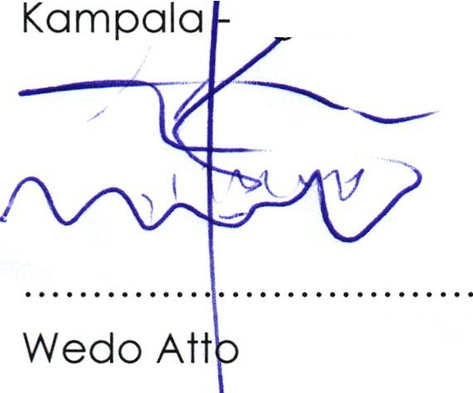
Declared and signed at Speke Resort and Conference Centre, Munyonyo, U on the Friday 22nd November 2019.

President EAAACA/ Deputy Commissioner Federal Ethics and Anti-Corruption Commission Federal Democratic Republic of Ethiopia

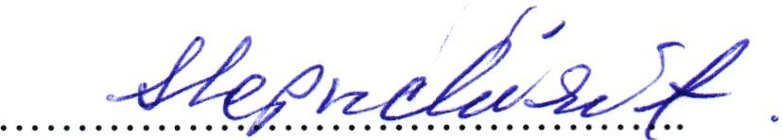
Sophia Le p uc hi rit
Vice President EAAACA/Vice Chairperson Ethics and Anti-Corruption Commission Republic of Kenya

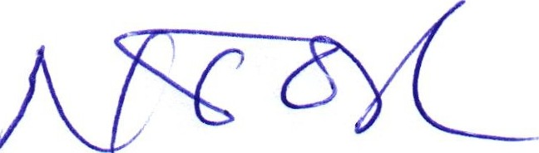

Hon Ngor Kolong Ngor Chairperson
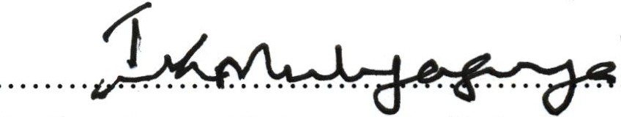
South Sudan Anti-Corruption Commission South Sudan

Justice Irene Mulyagonja Kakooza Inspector General of Government Inspectorate of Government Republic of Uganda

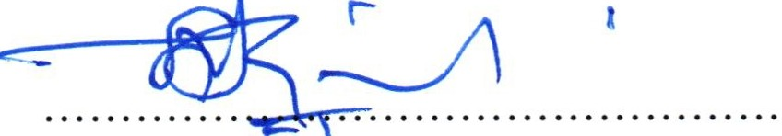
Emmanuel Kibeshi Kiyabo Fo r: Director General
Prevention and Combating of Corruption Bureau United Republic of Tanzania
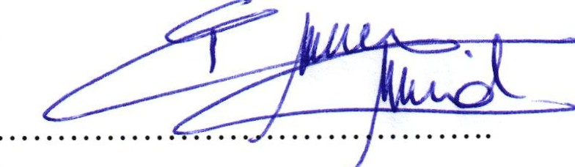
Mohammad Idriss abar
For: Inspector General of State Inspectorate General
State of Djibouti

